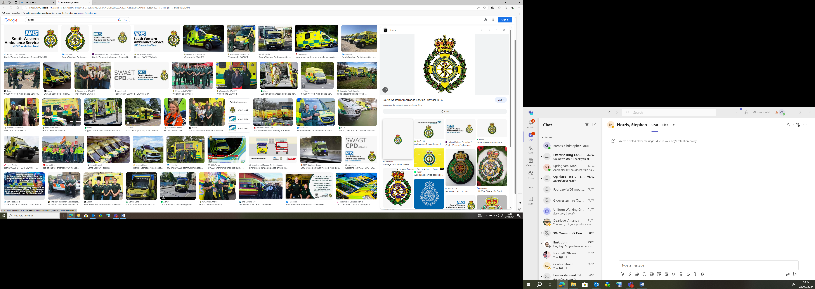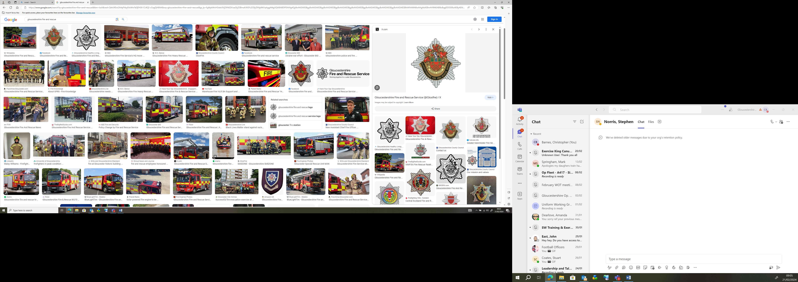

(Name of Establishment) Major Incident Initial Action & Emergency Service Information Card

Address;
Access;
RVP (out of line of site);
Responsible (and Deputy) Person (Including Contact Details);
Parent Reception Location & Contact details;

Ref’ | Initial Response Actions | Tick / sign / time
I1 | Hand Out Action Cards
I2 | Identify the best means of contact to all identified Leads
I3 | Take Grab Kit to RVP
I4 | Take Master Key’s, Access Cards and / or door codes to RVP
I5 | Start a log book
I6 | Dispatch responsible person and deputy to Parent / Guardian Reception Point (ensure you have a clear means of communication with them).
I7 | Identify the Police / Fire / Ambulance Commander as soon as possible (METHANE Report, JESIP Principles)
I8 | Re-enforce to Communications Lead and deputy to speak immediately to police media team to co-ordinate any messaging

Ref’ | Co-ordination – Information for Emergency Services | Tick / sign / time
I9 | Pupils / Staff on site;  - Number Injured  - Type (and seriousness) of injury  - Total number of persons remaining on site (Pupils / Staff / Visitors)  - What have those remaining been told (Lockdown / Evacuate / Invacuate etc)
I10 | Premise Information Box location:  Fire Alarm Panel location:  Gas isolation location:  Electric isolation location:  Water isolation location:
I11 | Construction of Building(s);
I12 | Maps (to take to RVP or place in Gerda box)  - Entire Site Map  - Internal Building Maps  - Location of Stronghold Rooms  - Location of CCTV room
I13 | Safe Word  - Ensure all Emergency Services know the current Safeword to identify themselves to those remaining on site
I14 | Hazards to Emergency Responders & location: (eg Location of Chemical Stores, LPG cylinders, Hidden Drops, Basements, Swimming Pools etc)
I15 | Suspects  - How many suspects?  - Descriptions  - What are they carrying (describe any weapons if possible, were they seen to re-load for example)  - Did they say or shout anything  - Are they still on site / active
I16 | Suspicious Packages;  H (Hidden) -  O (Obviously Suspicious) -  T (Typical) -  - Location (including any Hazards it is near too) -  - Access Routes (including any obstacles) -  - Description –  - Cordon -
I17 | Log in details ;  - School Social Media  - Remote CCTV log in  - School Website

